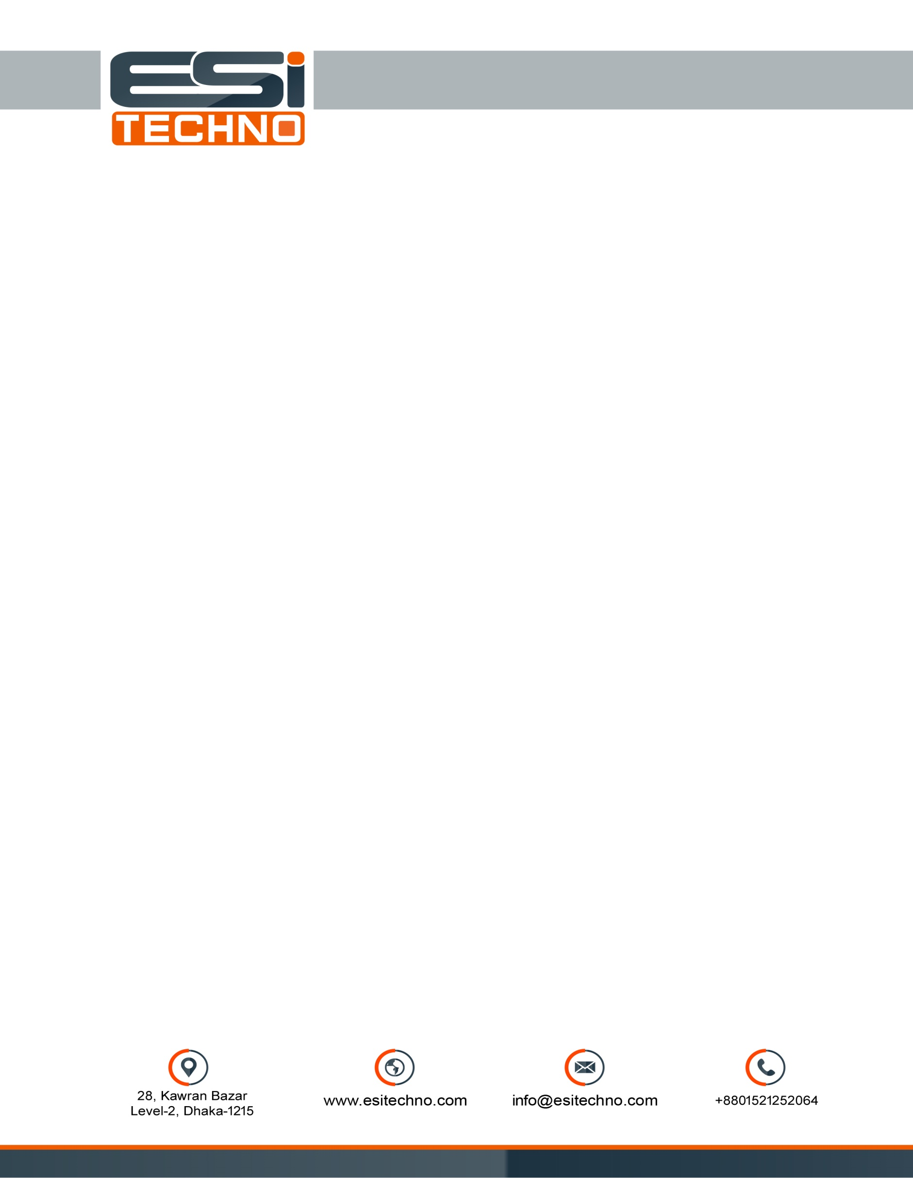

**Quotation**

Date: 06 Dec 2020

To

**ATN News Ltd.**

Hassan Plaza, 53 Kawranbazar

Dhaka

**Subject**: Quotation for Mine-Q8 4G Live Bonding Encoder.

|  |  |  |  |  |
| --- | --- | --- | --- | --- |
| **Sl** | **Product Description** | **Qty** | **Unite Price** | **Total Price** |
| **01** | **Mine-Q8 4G Live Bonding Encoder**   * Dual HDMI/SDI * 3 SIM/WiFi/Ethernet/USB Dongle * M Live App Control * Portable to carry * Portable Wireless 4g Streaming Encoder, HD live video streaming through RTMP/RTMPS/RTSP directly to Facebook, Youtube, Twitter etc. * Simultaneously bond up to 6 network links including support for 3*4G LTE cellular or 1*USB Dongle, WiFi and Ethernet. * Internal rechargeable battery provides up to 4-6 hours of continuous streaming. * Back-pack Bag | **04 Unit** | **1,04,000/** | **4,16,000/** |
| **02** | **Additional Equip:** Back-pack Bag | **01 Unit** | **2,500/** | **2,500/** |
| **Total:** | | | | **4,18,500/** |

**In word: Four Lac Eighteen Thousand Five Hundred Taka only.**

Payment:

* 70% Advance with work order. 30% at delivery.

Terms and Condition;

* Price quotation will valid up to 7 days.
* 1 (One) year warranty.
* 1 (One) year Cloud charge Free.
* Damage and burn case are not applicable for warranty.

Thanks

Md. Mehedi Hasan

Asst. Manager (Operation)



**Mine – Q8**

